Higher Education and Training

REPUBLIC OF SOUTH AFRICA

|  |  |
| --- | --- |
| |  | | --- | | MARKING GUIDELINE | |

# NATIONAL CERTIFICATE

APRIL EXAMINATION

## STRENGTH OF MATERIALS AND STRUCTURES N6

7 APRIL 2014

This marking guideline consists of 8 pagese

TI

### QUFSTION 1

1.1 b at 75 mm : a + 30 x 10 ..

0,0752

b at 125 mm : a +

0,1252

(1) (2) : 177,7781) - 641) 30 x 10 6

l) - 263,672 x 10 3

 — —16,875 x 10 6

b at 75 mm : ãHmax

0,0752

263,672 x 10 3

= -16,875 x 10 6

0,0752

a

OHmax ¯ —63,75MPa (tensile)€

b at 125 mm : aHmtn

0,1252

263,675 x 10 3

= -16,875 x 10 6 -

0,1252

(Thlmin = —33,75 (tensile)xf

(6)

1.2

#### ôdl = T(ãH — 0 X ÜR)

0,075

(30 x 10 6 - 0,29 x 30 x 10 6 ) 

200 x 10 9

ôdl = 7,9875 x 10 -6 m (2)

ôd2 = T(OH — 0 X (JR)

0,075

#### (-63,75 x 10 6 - x 30 x 10 6 )

41 x 10 9

ôd2 = -133,0793 x 10 -6 m (2)



Ad - ödl - öd2

* 7,9875 x 10 -6 (-133,0793 x 10 6

Ad = 0,141 x 10 -3 m v; (1)

1.5 Fg = g x P x 7TDL

x 30 x 10 6 0,075 xo,l x/

* 141,372 kN



2.1 wL2



2

#### 4 X 103 X

= 10 x 10 3 62

2

i

M - 132 klVmY

22 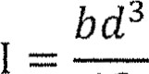

12

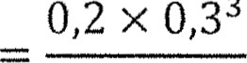

3

0,3

12

I = 450 x

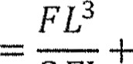wL4

max

3El 8El

10 x 10 3 x 6 3

1. x 200 x 10 9 x 450 x 10

= 8 x 10 -3 + x 10 -3

max ¯ 15,2 x 

(2)

(2)

1. X 10 3 X 6 4

8 x 200 x 10 9 x 450 x 10



-6

-6

(3)

23

2/31

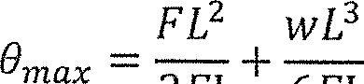

6El

10 x 10 3 x 6 2 4 x 10 3 x 6 3

2 x 200 x 10 9 x 450 x 10 6 x 200 x 10 9 x 450 x 10



-6

-6

2 x 10 -3 + 1,6 x 10 3

|  |  |
| --- | --- |
| x 10 -3 rad -V | (2) |

2.4 M 3

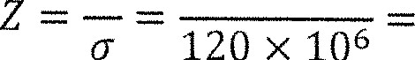

132

x

10

1100 x

from tables : I profile is 406 x 178 x 67,2 kg/m v (2)

|  |  |  |  |
| --- | --- | --- | --- |
|  | z 1189 x 10 -6 | | (2) |
| 2.6 | FpL3 FL3  3El 3El |  |  |
|  | divide by El : | Fpx63 10 x 770 x 6 3 4 X 648 X 64  3 3 8 |  |
|  |  | Fp = 19kN | (2) |

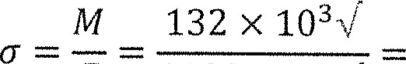2.5 132 X

111,02 MPav

### QUESTION 3

#### 3.1 TID2



0,22

31,416 x

4 4

#### ITD4 IT x 0,2 4

= 78,54 x 10 -6 m 4 V

64 64

- 31,226 x 10 3 +

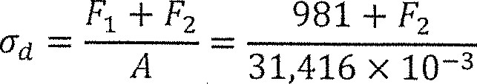

+

981



4-5 x 10 3 - (31,226 x 10 3 + 

 = 13,774 X 10 3 31,831F2V

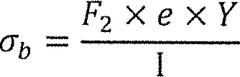

x 0,05 x

13,774 x 10 3 - 31,831F2 =

78,54 x 10 -6

 = 144,241 N (7)

3.2 

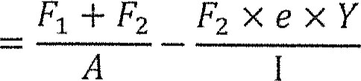



31,416 x 10 -3 78,54 x 10 -6

= 35,816 x 10 3 - 9,183 x 10 3 V"

 - 26,635kPa V

(4)

3.3

45 kPax

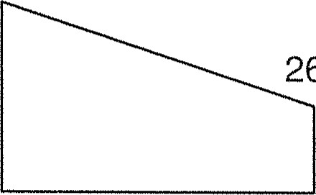26,635 kPav$

(2)

[13]

### QUESTION 4

4.1 WI = pgAl 2500 x 9,81  x 1 = 78,48 kN 

1/1/2 = pgAl - 2500 x 9,81 x  x 2 x x 1 = 78,48 klV

V = WI + W2 = 156,96 -v

(3)

4.2 1 — sin 28

0,361 v 1 Sin 28

pgh2Cll 1600 x 9381 x 3,2 2 x 0,361

 29,011 kN V

2 2 (2)

4.3 h h

Fp X — + Fg X WIXI + W2X2 = V X XR

Fp X + 29,011 X 1,07 + 78,48 X + 78,48 X 156,96 x 2

313,92V



(6)

4.4

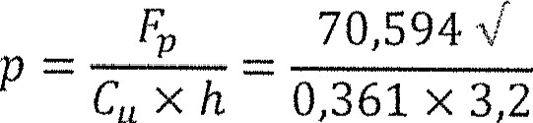

cuxh

= 59,633 kPa

(2)

[13]

### QUESTION 5

5.1 Mt = X Z X n = 100 x 10 6 x 1462 x 10 -6 x 4 = 584,8 kNm V

Mb = c x Z x n = 100 x 10 6 x 415,8 x 10 -6 x 16 = 665,28 kNm V

(2)

5.2 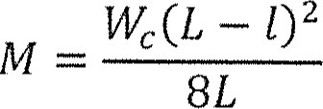

584,8 x 10 3 =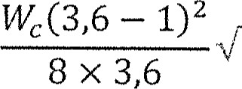

wc = 2491,456 kN v'

#### WT = vvc + WF = 2491,456 x 10 3 + 200 x 10 3 = 2691,456kN V (4)



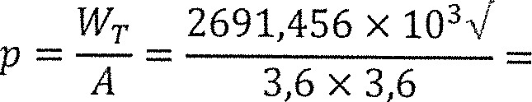5.3

207,674 kPa v

(2)

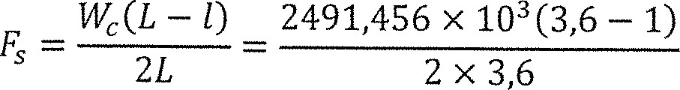5.4

- 899,692 klV

899,692 x

54,1 MPa V nhtl 4. x 0,4572 x 0,0091

899,692 x 10%/

27,246 MPa 

16 x 0,3127 x 0,0066 (5)

### QUESTION 6

6.1 bn2

mAs(d — n)

2

#### 200712

= 15 x 1,257 x 10 3 (300 2

5,305 x 10 -3 n 2 = 300 -n

5,305 x 10 -3 712 + n- 300

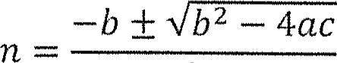

2a

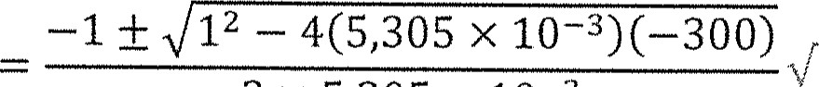2 x 5,305 x 10 -3

n = 161,5 mm (4)

|  |  |  |  |
| --- | --- | --- | --- |
| 6.3 | 5,2 x 10 6 x x 0,162 |  | (2) |
|  | x 0,246 | = 20,723kNm |  |

### 62

= 140 x 10 6 x 1,257 x 10 -3 x 0,246 = 43,279kNm 

(2)

6.4 M = 20,723 kNm (maximum

-8- 

6.5 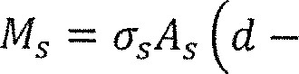4)

20,723 X 10 3 X 1,257 X 10 -3 (0,3

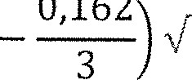

0,162

= 67,0167MPax! (2)

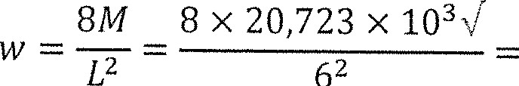6.6

4,605 kN/m v

(2)

#### QUESTION 7

7.1 = WX2 = 6 X 103 X 772 462 klV 

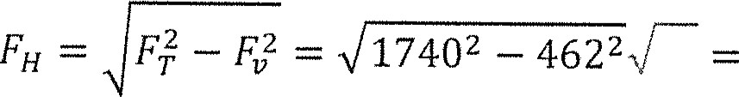 1677,544kN  (3)

7.2 vvxl2 6 x 10 3 x 63 2 V

##### = 7,1mV

2FH 2 x 1677,544 x 10 3

(2)

7.3 2 x 7,1 2

I1 = Xl += 63 += 63,533 m V 3X1 3 x 63

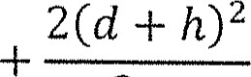2 x (7,1 +

12 = X2= 71 += 72,1m N/"

3X2 3 x 71

2 = 63,533 + 77,973 = 135,6m (3)



7.4 va= 1062 - 462 = 600 klV V

0 = cos-I FBI) = cos -l = 69,8 0 V

1740 (2)

A

7.5 Ha = = 1740 sin 69,8 = 1633,279kN N/

M = (FH - FHa)H = (1677,544 -  885,3kNm  (3)

[13]

-9- 

#### QUESTION 8

8.1 T' =  1,14 x 35 39,9 V

|  |  |  |
| --- | --- | --- |
|  | 252 + 39,928/ - 47,1kNm | (2) |

8.2  M2 + T'2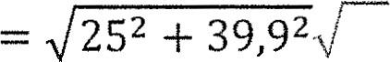

8.3 Me — 0,5 M + 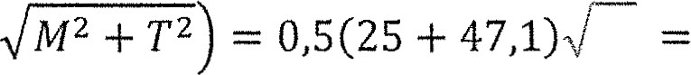 36,05kNm  (2)

|  |  |
| --- | --- |
| 8.4 16 x 0,18 x 47,1 x 10 3 %/  16DTe  Tt(D  - 51,256 MPaV | (2) |

8.5 32DMe 32 x 0,18 x 36,05 x 10 3

78,462 MPa (2)

Tt(D 4 — d 4 ) - 0,12 4 )

TOTAL: 100